THE TRUTH ABOUT PUBLIC-PRIVATE PARTNERSHIPS
A “public-private partnership,” or PPP, is a form of privatization in which a private, generally for-profit corporation takes over some aspect of a project or service that is traditionally provided by the government. The World Bank and private industry began pushing the “PPP” term and model after disastrous experiments with water privatization in the 1990s made privatization politically unpopular, as epitomized in the conflict known as the Cochabamba, Bolivia “water wars.”
Like the earlier privatization model, PPPs are bad for people, water systems, and democracy. The private water industry and World Bank make several positive-sounding claims about PPPs—but the facts tell a different story.
In water systems, PPPs may include:
- corporate operation and management of treatment or distribution systems

- corporate financing of capital projects

- a range of other models, including consulting contracts
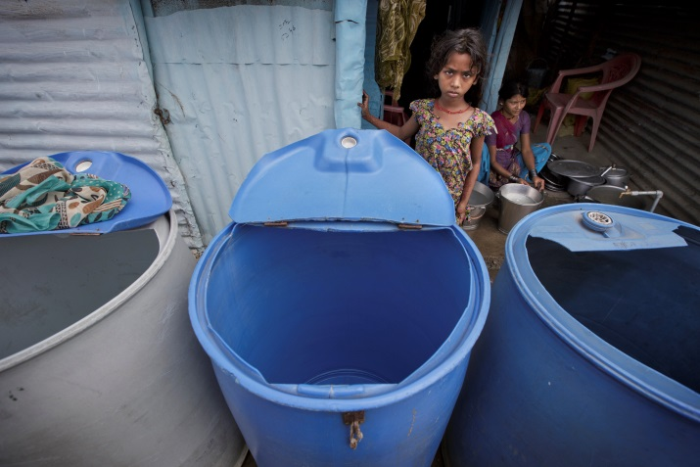
PHOTO: Low-income residents in Nagpur, India have anywhere from limited access to clean water to none at all. Here, residents rely on water tankers that come only once every other day. (Photo by Kuni Takahashi)

THE CLAIM
PPPs bring money to projects that governments cannot.

THE TRUTH
Governments are generally best positioned to raise funds—and don’t expect to make a profit off people’s basic needs.

THE FACTS
- A 2009 World Bank review of the outcomes of 15 years of water PPPs found that corporations often "failed to invest the amount of private funding they had originally committed, and did not always meet their original contractual targets for coverage."
- The report concluded that "in most of the developing world, the bulk of the large capital outlays required to expand access in the near future will have to come from public sources."
- While some PPPs do involve private financing, private corporations always expect to make their money back—plus a profit.
  - Financing is money provided for temporary use, usually with an expectation of repayment, often with interest.
  - Rates often rise with PPPs because private finance builds in interest and profits that are often charged back to ratepayers.
  - In Manila, the Philippines, rates rose approximately 850 percent under a PPP with Manila Water Company as the corporation charged households to cover corporate costs—including income tax and promotional expenses.
- Governments can fund water infrastructure as part of national, state, and local budgets—a vast majority of the world’s public water systems have been funded by governments.
  - Funding is money provided for long-term or permanent use, without a necessary expectation of repayment or profit. Government funding allows utilities to set policies that prioritize health and human rights over corporate profits.
- What’s more, many governments can borrow at lower interest rates than corporations.

Case in point: Nagpur, India
In Nagpur, a World Bank-backed PPP that has been lauded as a global success story has been plagued by failure to meet infrastructure goals, delays, labor abuses, and interruptions in service. The corporate “partner”—a Veolia venture—is being paid more than double what it would cost to run the system publicly, yet the corporation is not contributing any capital investment.

- corporate financing of capital project

- a range of other models, including consulting contracts

Case in point: Hoboken, NJ, USA
In Hoboken, a PPP obligates the United Water corporation to spend only $350,000 a year on infrastructure, even though water main breaks have left thousands without water, and the city has had to find resources for much-needed infrastructure repair.

THE CLAIM
A PPP will maintain and expand infrastructure.

THE TRUTH
Worldwide, PPPs have repeatedly failed to invest in needed infrastructure.

THE FACTS
- Water industry representatives, the World Bank, and government officials have all acknowledged that PPPs do not bring funding for the expansion or repair of water infrastructure.
- Antoine Frérot, CEO of one of the world’s largest water corporations, Veolia, writes, “There are those who would like to count on large private operators to finance the vast infrastructure programmes that are needed around the globe, but they fail to grasp...an operator is not a banker! The mission of an operator is to manage the infrastructure for which he [sic] is responsible, not to finance it”
- The World Bank’s in-depth review of water public-private partnerships over the past 15 years found that private utilities have often failed to meet contractually agreed targets for expanded access.
PHOTO: Increased bill collections and rates hiked more than fivefold have made drinking water unaffordable for Manila’s low-income people. Here, residents of Quezon City, Metro Manila demand the immediate implementation of rate cuts. (Photo by Sunshine Lichauco de Leon)

THE CLAIM
PPPs are more efficient than public systems.
THE TRUTH
The “efficiency” PPPs deliver amounts to reckless cost-cutting and the extraction of profits at the expense of human rights.
THE FACTS
- PPPs bring price hikes, layoffs, shutoffs, and aggressive bill collection.
- A World Bank study of 71 nations—from Latin America to Africa to East Asia—found “employment decreases” of 22 percent among water utility workers after a PPP.
- The United Nations Research Institute for Social Development found that “in most cases, it is found that prices increase” after private sector participation.
- Private providers must generate profits and cannot use progressive rate structures to ensure that low-income communities have adequate access.
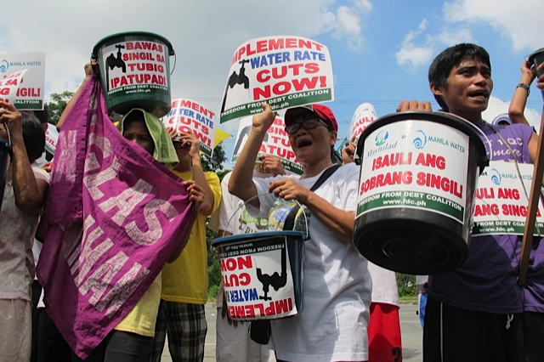
Case in point: Nagpur, India
In November 2015, a “massive disconnection drive” cut off scores of unregistered connections without regard to peoples’ access to water.
THE CLAIM
PPPs protect against corruption.
THE TRUTH
Governments do not have a monopoly on corruption; some corporations have been found to be highly corrupt.
THE FACTS
- The bidding process for long-term, multi-million dollar contracts is extremely vulnerable to corruption, meaning PPPs exacerbate the risk of malfeasance.
- Because people aren’t served by competing networks of piped infrastructure, water is considered a natural monopoly. Only public accountability and regulatory oversight can rein in abuses.
- Public oversight is much weaker with a privatized system because of decreased access to records and decision makers.

THE CLAIM
PPPs don’t threaten democratic control or human rights.
THE TRUTH
The private water industry and World Bank-backed privatization efforts have eroded democracy, national sovereignty, and human rights.
THE FACTS
- In the United States, the water industry has promoted legislation removing existing popular vote requirements before water system sales or leases.
- contract with Suez, the corporation brought a suit in the World Bank’s arbitration forum, winning more than $400 million for breach of contract after failing to meet its own infrastructure investment promise.
- In Lagos, Nigeria, a World Bank-backed effort to secure a PPP included a campaign to “enlighten” Nigerians rather than seek their feedback.
- In Indonesia, the constitutional court revoked a 2004 water law allowing privatization on the grounds that it can interfere with the human right to water.

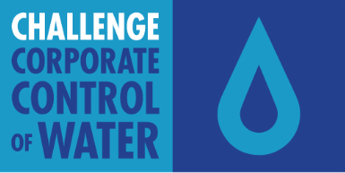
Challenge Corporate Control of Water is a Corporate Accountability campaign to advance and protect the human right to water, secure people’s access to water, preserve and protect water resources and systems for the public good, and preserve water resources as an ecological trust.
Corruption has been alleged even in PPPs called “successes” by the World Bank:
- In 2015, the former head of Veolia’s Bucharest operations was charged with bribing officials to grant rate increases. Veolia also allegedly paid media outlets to prevent negative coverage and hired spies to make sure its own employees kept its activities secret.
- In Nagpur, multiple corruption allegations have been made against the private “partner”—a Veolia venture—including an inquiry into charges of accepting bribes to lower water bills.

CAMPAIGN HEADQUARTERS
10 Milk Street, Suite 610
Boston, MA 02108
617.695.2525
Info@CorporateAccountability.org

